Aaron Andal

UF3 - ADMINISTRACIÓ AVANÇADA DE XARXES
Activitat 2.2. Enrutament complex d'VLAN

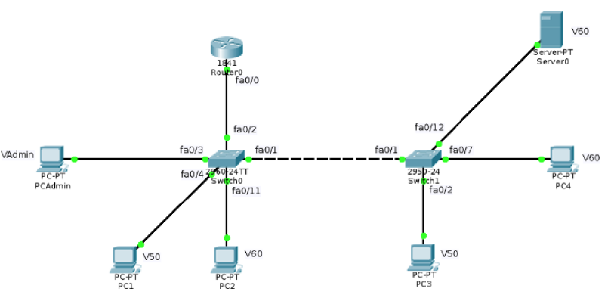
Amb les següents VLAN:
● VLAN 1 - Nativa
● VLAN 50 - 172.24.50.0/24
● VLAN 60 - 172.24.60.0/24
● VLAN 100 (Administració) - 172.24.100.0/24
I la següent distribució entre VLAN, switchs i ports:
VLAN Switch0 Switch1
1 fa0/1 i fa0/2 fa0/1
50 fa0/4 - fa0/10 fa0/2 - fa0/6
60 fa0/11 - fa0/24 fa0/7 - fa0/12
100 fa0/3 none

Digueu quines són les configuracions necessàries per tal que: tots els PC i el Server0 s'han de poder fer ping entre ells.

Als switch s’ha de configurar les vlan amb interfícies troncals(al S0 la fa0/1 i fa0/2 i al S1.
la fa0/1).
Al router s’ha de configurar les tres interfícies virtuals.

Switch0
CONFIGURAR LES VLAN

Switch(config)#int range fa0/4-10
Switch(config-if-range)#switchport mode access
Switch(config-if-range)#switchport access vlan 50
% Access VLAN does not exist. Creating vlan 50
Switch(config-if-range)#no shutdown
Switch(config-if-range)#exit

Switch(config)#int range fa0/11-24
Switch(config-if-range)#switchport mode access
Switch(config-if-range)#switchport access vlan 60
% Access VLAN does not exist. Creating vlan 60
Switch(config-if-range)#exit

Switch(config)#int range fa0/11-24
Switch(config-if-range)#no shutdown
Switch(config-if-range)#int fa0/3
Switch(config-if)#int fa0/3
Switch(config-if)#switchport mode access
Switch(config-if)#switchport access vlan 100
% Access VLAN does not exist. Creating vlan 100
Switch(config-if)#no shutdown
Switch(config-if)#exit

Switch(config)#int fa0/1
Switch(config-if)#switchport mode trunk
Switch(config-if)#switchport trunk allowed vlan 50,60
Switch(config-if)#no shutdown
Switch(config-if)#exit

Switch(config)#int fa0/2
Switch(config-if)#switchport mode trunk
Switch(config-if)#switchport trunk allowed vlan 50,60,100
Switch(config-if)#no shutdown
Switch(config-if)#exit

Switch1
CONFIGURAR LES VLAN
Switch(config)#int range fa0/2-6
Switch(config-if-range)#switchport access vlan 50
% Access VLAN does not exist. Creating vlan 50
Switch(config-if-range)#no shutdown
Switch(config-if-range)#exit

Switch(config)#int range fa0/7-12
Switch(config-if-range)#switchport mode access
Switch(config-if-range)#switchport access vlan 60
Switch(config-if-range)#exit

Router0
CONFIGURAR LES INTERFÍCIES VIRTUALS I LES VLAN
Router(config)#int fa0/0.50
Router(config-subif)#ip address 172.24.50.1 255.255.255.0
Router(config-subif)#encapsulation dot1Q 50
Router(config-subif)#exit

Router(config)#int fa0/0.60
Router(config-subif)#ip address 172.24.60.1 255.255.255.0
Router(config-subif)#encapsulation dot1Q 60
Router(config-subif)#exit

Router(config)#int fa0/0.100
Router(config-subif)#ip address 172.24.100.1 255.255.255.0
Router(config-subif)#encapsulation dot1Q 100
Router(config-subif)#exit

Comprovacions de connectivitat
PCAdmin
C:\>ping 172.24.60.3

Pinging 172.24.60.3 with 32 bytes of data:

Reply from 172.24.60.3: bytes=32 time<1ms TTL=127
Reply from 172.24.60.3: bytes=32 time=1ms TTL=127
Reply from 172.24.60.3: bytes=32 time=1ms TTL=127
Ping statistics for 172.24.60.3:
Packets: Sent = 3, Received = 3, Lost = 0 (0% loss),
Approximate round trip times in milli-seconds:
Minimum = 0ms, Maximum = 1ms, Average = 0ms

PC1
C:\>ping 172.24.60.3

Pinging 172.24.60.3 with 32 bytes of data:

Reply from 172.24.60.3: bytes=32 time<1ms TTL=127
Reply from 172.24.60.3: bytes=32 time<1ms TTL=127
Reply from 172.24.60.3: bytes=32 time=15ms TTL=127
Reply from 172.24.60.3: bytes=32 time<1ms TTL=127
Ping statistics for 172.24.60.3:
Packets: Sent = 4, Received = 4, Lost = 0 (0% loss),
Approximate round trip times in milli-seconds:
Minimum = 0ms, Maximum = 15ms, Average = 3ms

PC2
C:\>ping 172.24.60.3

Pinging 172.24.60.3 with 32 bytes of data:

Reply from 172.24.60.3: bytes=32 time<1ms TTL=128
Reply from 172.24.60.3: bytes=32 time<1ms TTL=128
Reply from 172.24.60.3: bytes=32 time<1ms TTL=128
Reply from 172.24.60.3: bytes=32 time<1ms TTL=128
Ping statistics for 172.24.60.3:
Packets: Sent = 4, Received = 4, Lost = 0 (0% loss),
Approximate round trip times in milli-seconds:
Minimum = 0ms, Maximum = 0ms, Average = 0ms

PC3
C:\>ping 172.24.60.3

Pinging 172.24.60.3 with 32 bytes of data:

Reply from 172.24.60.3: bytes=32 time<1ms TTL=127
Reply from 172.24.60.3: bytes=32 time<1ms TTL=127
Reply from 172.24.60.3: bytes=32 time<1ms TTL=127
Reply from 172.24.60.3: bytes=32 time<1ms TTL=127
Ping statistics for 172.24.60.3:
Packets: Sent = 4, Received = 4, Lost = 0 (0% loss),
Approximate round trip times in milli-seconds:
Minimum = 0ms, Maximum = 0ms, Average = 0ms

PC4

C:\>ping 172.24.60.3

Pinging 172.24.60.3 with 32 bytes of data:
Reply from 172.24.60.3: bytes=32 time=4ms TTL=128
Reply from 172.24.60.3: bytes=32 time<1ms TTL=128
Reply from 172.24.60.3: bytes=32 time=5ms TTL=128
Reply from 172.24.60.3: bytes=32 time=5ms TTL=128
Ping statistics for 172.24.60.3:
Packets: Sent = 4, Received = 4, Lost = 0 (0% loss),
Approximate round trip times in milli-seconds:
Minimum = 0ms, Maximum = 5ms, Average = 3ms

